# Game Design Document - Vegistation

## **Contents**

**Game Outline**

*Chosen genre*

**Characters and Controls**

*Main Character*

*Character Designs*

*Character Specifications*

**Main Gameplay**

*Objectives*

*Goal*

**Game World**

*Level Design*

**Gameplay Mechanics**

*Mechanics*

**Enemies**

*Ai Behaviour*

**Cutscenes**

## Game Outline

The chosen genre for this project is horror and puzzle.

The game is set inside a laboratory. The player will explore the laboratory after being sent to the building to solve puzzles, defeat mutations and remove the mutations from existence.

The horror aspect will be the environment and the mutations along with the ambiance, sounds and effects that the environment will give off along with the eery sounds the mutations will make.

The puzzle aspect will consist of finding items and placing them in correct orders, electrical based puzzles, piecing together collective information for formulate final results and creating mixes of formulars to match the result with guidance from finding the final collective information to help remove, and exterminate, the mutations before spreading.

The game will be targeted at those above the ages of twelve.

## Characters And Controls

Our Main character of this game will be a scientist working in a laboratory as they are working on perfecting on enlarging vegetables to solve lack of resources and food. During the start of our game the player scientist will be having a day off at home was not present for the disasters about to inflict harm on many lives.

This game will be a first-person point of view game which means it will not matter what the character looks likes.

The player will be able to hold items and weapons within the games allowing them to complete puzzles, pass enemies and collect intel on the current situation they missed and how they can fix the mess they were assigned.

## Main Gameplay

The main aim of the game is to defeat the mutated vegetables and stop the spread and growth of the mutations. The player must stop the army of vegetables growing to survive and leave the laboratory in one piece.

The game starts with a cutscene of scientist from the laboratory conducting their experiment before disaster strikes and the experiment goes wrong, in a last resort to stop the research from spreading outside the containment area they call you, the player, to come to the laboratory on your day off by leaving a message of distress and urgency.

The player processed to head to the laboratory in the dark as they reach the entrance. The interactive gameplay will start as they will enter and after some searching will discover blood stains and marks on the ground as no survivors are in sight. The player must find out what happened. There being security cameras they can look at the surveillance footage to find out what happened, however, there will be no power and the first puzzle of the game will be to restore power which will introduce the player to puzzles and encourage them to search for items.

Once the player has restored power the elevators will be up and running again allowing the mutated carrot to come up to the floor, the player will encounter the mutated carrot and learn about the attacking mechanics of the game.

Once proceeded they will head to the next floor where they will see the blood stains and mess from the remains of the failed experiment. The player will complete puzzles to get around, find information on how to stop the mutation. They will encounter more enemies them being more difficult to fight and hold up against.

Once the player reaches the bottom, they will prepare the solution to wipe out the mutated creatures in the sprinkler system, however, they will encounter the boss first, the boss will be a large mutation as the player will have to face off against it with the weapons they have collected on the way.

After the boss is taken down the player will complete the last and final mission where they will finish the game leaving the building after exterminating the mutations.

## Game World

**Security Room**

**Cafeteria**

**Front Entry – Players Starting Point**

**Staff Break room – No Entry**

**Storage Room 2**

**Storage Room 1**

**Male Toilets**

**Meeting Room**

**Power Room**

**Freezer**

**Kitchen**

**Stairway**

**Female Toilets**

**Elevator**

**Office 1**

**Office 2**

**Rooms**

**Front Entry** will be where the player starts, the **Staff Breakroom** is locked and non-accessible to the player. Going through the corridor there will the **Elevators** will be unavailable until the player

## Gameplay Mechanics

**Player:**

**Items:**

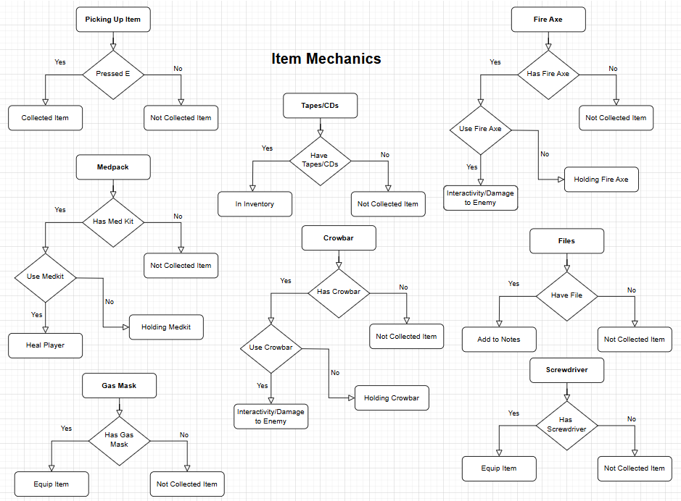

**Enemies:**

## Enemies

In this game there are six types of enemies and a boss. The enemies and boss are all mutated vegetables.

Each enemy has a different unique way of moving and attacking. The player will encounter different enemies on different levels and in different rooms specific to their nature and the boss can be found at the end of the game in the last room the player will be sent too.

On the first level the player will encounter the lower tier of enemies.

**The Lower Tier:**

The Models below were made from clay to represent the design of the characters.

**The Carrot**

The Carrot is the first enemy the player will encounter.

Movement:

* Slow Movement
* Hops around on one leg
* Patrols Rooms

Attack and Abilities:

* Medium distance
* Long slender arms
* Weak attack
* Has no special ability

Heath, Damage and Weak points:

* Has 60 HP
* Deals 5 damage per hit
* Main Body is weak point

**The Tomato**

Movement:

* Slow Movement
* Hops around
* Stays Idle in Rooms will follow player

Attack and Abilities:

* Long distance
* Spits tomato seeds at Player
* Weak attack
* Leaves tomato juice on the ground, player will slip on it

Heath, Damage and Weak points:

* Has 30 HP
* Deals 10 damage per hit
* Main Body is weak point

**The Mushroom**

Movement:

* Doesn’t move
* Stays Idle in Rooms on the ground

Attack and Abilities:

* Medium range
* Explodes like a landmine when the player stands on then
* Medium attack

**The Higher Tier:**

Heath, Damage and Weak points:

* Has 10 HP
* Deals 30 damage per explosion
* Main Body is weak point

**The Onion**

Movement:

* Medium Movement
* Rolls around
* Looks around Idle in Rooms will roll after player

Attack and Abilities:

* Increasing range
* Breaths out onion gas that makes the players eyes watery and impairs vision
* Inhaling for long periods of time will cause damage
* Weak attack
* Leaves tomato juice on the ground, player will slip on it

Heath, Damage and Weak points:

* Has 50 HP
* Deals 2 damage per second
* Main Body is weak point

**The Corn**

This Enemy will have legs made of the stork and leaves

Movement:

* Slow Movement
* Stomps around
* Walks around big rooms

Attack and Abilities:

* Long distance
* Pops corn at Player
* Weak attack
* Knocks player back with stomping

Heath, Damage and Weak points:

* Has 70 HP
* Deals 40 damage per hit
* Corn centre is weak point

**The Broccoli**

This Enemy has a spring at the bottom to move around

Movement:

* Fast Movement
* Uses spring at bottom to bounce around
* Springs around in rooms, will follow player

Attack and Abilities:

* As soon as in sight
* Uses eye to force the player too look at their eye
* Medium Attack
* Leaves tomato juice on the ground, player will slip on it

Heath, Damage and Weak points:

* Has 80 HP
* Deals 10 damage per stare
* Eye is weak point

## Cutscenes

During this game there will be cutscene.

**The First Cutscene**

Staff within the Laboratory will experience an experiment go wrong as one of the employees will send the player an alert message to come into the laboratory to the player on their day off. The player will leave their home and head out for the Laboratory.

**The Second Cutscene**

The player will switch on the power which will restore the elevator it now in operation. The elevator will be sent down. The player will review over the footage watching as the vegetables during the experiment mutate an attack the employees, while the player is watching the footage the elevator is still making its way down. Once the footage has ended the elevator will have made it’s way to the top, as the doors open it will reveal that there is a mutated carrot that has travelled up the elevator the player unaware.

**The Third Cutscene**

Player will encounter boss in the testing chamber.

**The Forth Cutscene**

Player will leave this place alive and uninfected